CLASS DESIGN
- Class “ProductController”
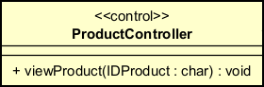

Attribute None
Operation
# | Name |  | Return type | Description (purpose)
1 | viewProduct |  | void | Send request to search that product and view that product

Parameter:
- IDProduct – ID product used to search product.
Exception:
- viewException: if responded with error that transaction is failed
State None
Method None

- Class “ProductDetailScreen”
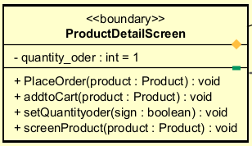
Attribute
# | Name | Data type | Default value | Description
1 | Quantity_order | int | 1 | Set quantity of that product in screen to order

Operation
# | Name | Return type | Description (purpose)
1 | PlaceOrder | void | Save the transaction between software and interbank
2 | addtoCart | void | Add product into your cart
3 | setQuantityorder | void | Add or minus Quantity_order, true is add, false is minus
4 | screenProduct | void | Screen out that product
Parameter:
- product – product information.
- sign – add or minus quantity of one product.
Exception:
- viewException: if responded with error that transaction is failed
Method None
State None

- Class “ListProductScreen”

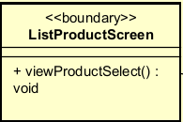

Attribute None
Operation
# | Name | Return type | Description (purpose)
1 | viewProductSelect | void | Get id product select and request to product conctroller

Parameter: None
Exception: None

State None
Method None

- Class “RentedBikeInfoScreen”
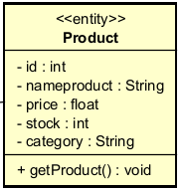

Attribute

# | Name | Data type | Default value | Description
1 | id | Int | NULL | Id of the product
2 | nameproduct | String | NULL | Name of the product
3 | price | float | NULL | Price of that Product
4 | stock | Int | NULL | Quantity remain of the saler
5 | category | String | NULL | Category of the product

Operation
# | Name | Return type | Description (purpose)
1 | getProduct | Product | Return product infomation

Parameter: None
Exception: None
Method None
State None

- Class “PaymentHandler”

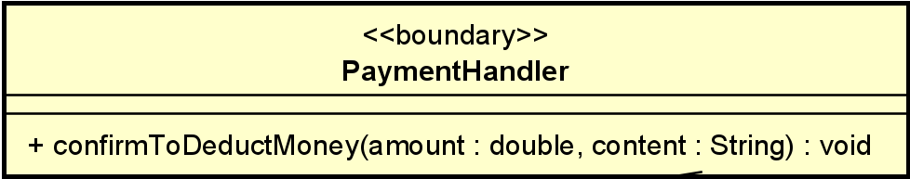

Attribute
Operation
# | Name | Return type | Description (purpose)
1 | confirmToDeductMoney | void | Confirm to deduct money from card to pay for renting bike

Parameter:
- amount: total amount that interbank will deduct from customer’s card
- content: content of transaction
Exception: None
Method None
State None

